# Appendix 01:

**Guideline for using BPMN notation to draw flowcharts**

1. **Content**
   1. ***Symbols BPMN use to draw process***

| **Sign** | **Explain** |
| --- | --- |
|  | Start event |
|  | End event |
|  | Activities or works in the process |
|  | A subprocess is a complete process, but in the process is reviewing it considered as an activity in the process. |
|  | Exclusive Gateway use for branching or merge, only one exit branch when separate and one entry branch when combine |
|  | Parallel Gateway use for branches are executed in parallel before branching or executed in parallel after branching |
|  | Inclusive Gateway use for branching or combine, there can be multiple entry branches to be performed after branching and multiple entry branches to be performed before branching. |
|  | Sequential connection is used to connect events, activities, subprocesses, Gateway together, the order of execution is in the direction of the arrow. |
|  | Information connection represents the flow of information exchange between one process and another |
|  | Links are used to represent relationships between data objects, annotations, and data warehouse with events, operations, subprocesses, and branching/branching points.  With data objects and data warehouses, it is possible to use a link symbol with an arrow to represent the direction of information. For comments, use only the link symbol without the arrow. |
|  | Pool is used to contain all process |
|  | Lane is used to distinguish and draw the activities and work of the subjects participating in the process. |
|  | Document, information used, referenced or created in the process.  Description of documents, information can be physical objects such as documents, can also be digital objects such as online orders, used, referenced and created during execution process. |
|  | Comments or notes are used to describe more information and easier understand |
|  | Data warehouse is used to describe data warehouses used to extract information or store information in a process |

* 1. ***Gateway***

There are 3 common types of Gateway:

* **Exclusive Gateway:**
* ***Separate branch:*** Used to create alternate threads of the process in case multiple alternate threads occur based on various conditions (these conditions are not mutually exclusive) however only one of the alternate branches that is selected (when the correct condition is met) to continue executing the main thread. If no thread meets the condition, the process defaults to next execution of the specified default thread. Can use 2 symbols:

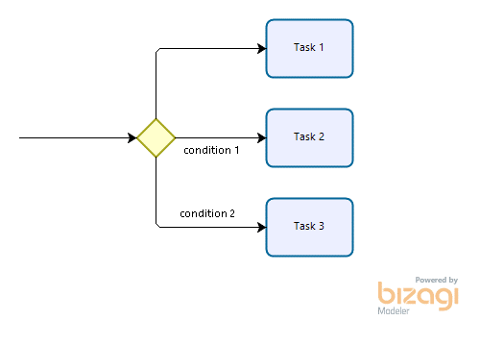 Or 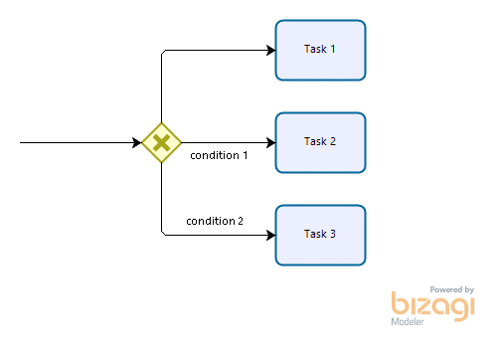

* It is recommended to name this gateway when branching in the form of a question with the answer being conditions written on streams for easy understanding by readers.
* Write clearly conditions to the outputs of this gateway.
* The default alternate flow can be specified for this gateway so that the process continues execution in case none of the conditions are true, the default flow is denoted by drawing an extra dash at near the base of the arrow and no conditions attached.
* Conditions should not be mutually exclusive, to avoid the case where multiple conditions are true, which will lead to incorrect execution of the correct flow.
* ***Cobine branch:*** Used to merge two or more process streams together into a single thread, and in each particular case of process execution only one input stream is followed by output. Can use 2 symbols:

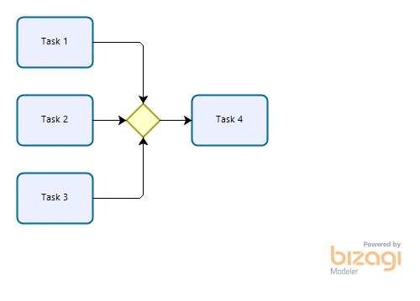 Or 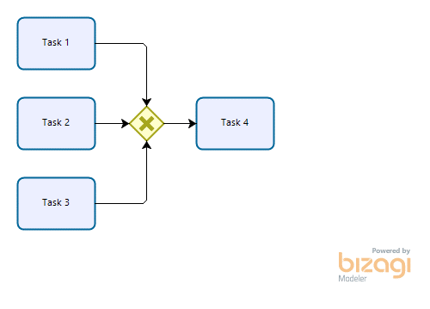

* **Parallel Gateway:** used to create new threads that execute in parallel without having to check any conditions.

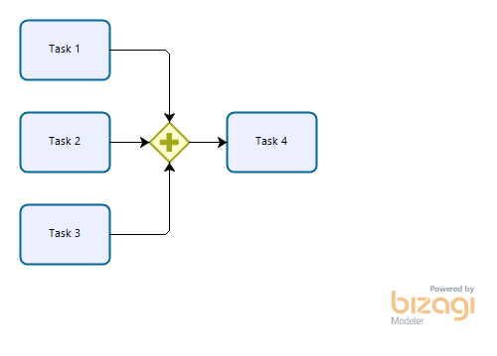Or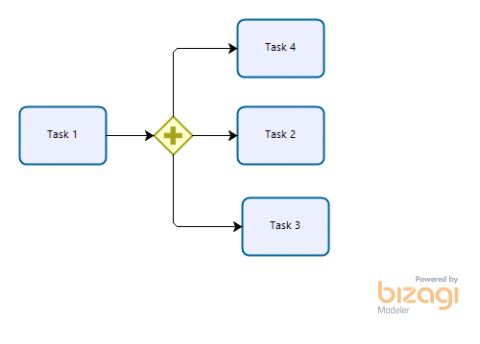

* **Inclusive Gateway:** It can be considered as a Excluesive Gateway and Parallel Gateway.
* ***Separate branch:*** used to generate alternate streams based on different conditions (these conditions are not mutually exclusive). Other than the exlusive gateway, here all conditions are evaluated. When a condition evaluates to true, its alternate flow takes effect. Effective streams will be executed. If no thread meets the condition, the process will follow the specified default thread.

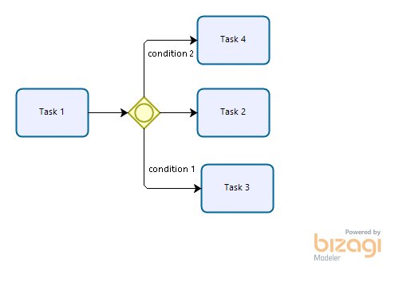

* ***Combine branch:*** used to merge branches. Unlike an exclusive gateway (which executes only which flow comes first) and a parallel gateway (which executes all incoming flows), an inclusive gateway when used to A branching merge will continue to execute the output stream only if, in its input flows, the flows (which take effect after a inclusive gateway) have been executed.

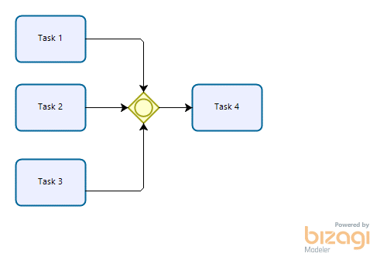

*Note:*

* Write clearly conditions to the outputs of the branching/joining point
* The default alternate flow can be specified for the branching/inclusion point so that the process continues execution in case none of the conditions are true, the default flow is denoted by drawing an extra dash at near the base of the arrow and no conditions attached
* Conditions are not mutually exclusive.
  1. ***Exclusive Gateway used for repeated tasks***

Exclusive Gateway can also be used to describe a work that is repeated or repeated in a process.

Example: a software development process.

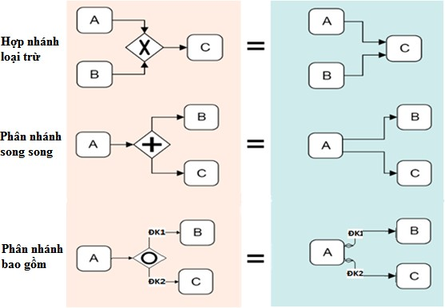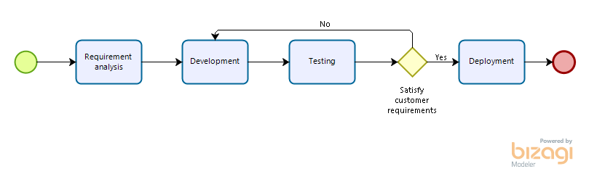

Compare:

1. **Sub - Process**
   * + In a process many times there can be activities that are a process in another business. When shown on the flowchart, the more component processes will become more complex and difficult to read, difficult to follow all the execution flows. Furthermore, many readers are not interested in the details of the steps in that subprocess, so it is possible to hide the details of the subprocess in the large process's flowchart.
     + BPMN offers a solution to the above problem by using Sub - Process notation.

|  |  |
| --- | --- |
|  | Sub - Process represents an existing process, but in the flowchart under consideration, the details in that subprocess need not be concerned. Subprocess notation should be used in the flowchart when there are already many components (no more than 30 activities, events, Gateway are recommended in the flowchart) which makes it difficult to read and posible make mistake. |

For example:

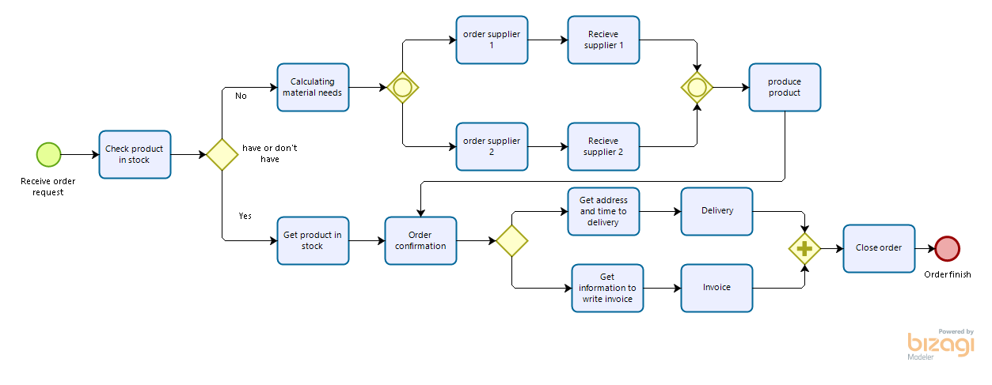

After converting use Sub – Process

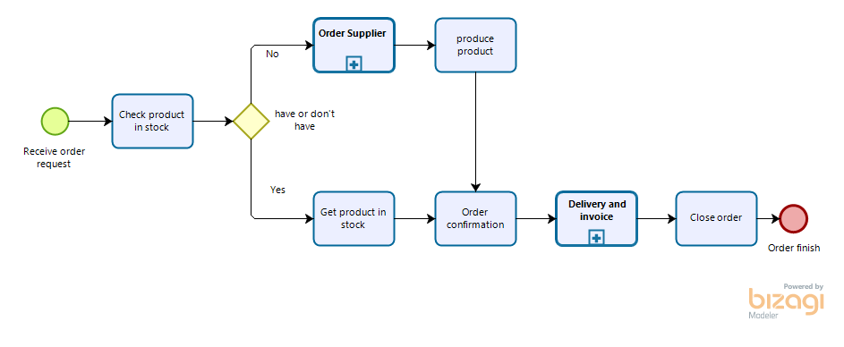

Note:

* + - Do not use Pool and Lane when drawing subprocess flowchart.
    - Should not show too many symbols about information artifact because it will cause confusion, difficult to read. It should be used only when absolutely necessary, expressing important relevant information.
    - Connection with data objects and data stores can use dotted lines or dotted dotted arrows without a circle at the base of the arrow (easily confused with arrows representing information flow between objects) to represent information direction.
    - Connection for captions using dotted lines, no arrows.

1. **Pool and Lane**

**Pool:** Pool is used to contain the entire flowchart of a process. Hence the Pool name is usually named after the process name. In the cooperation process flow chart (mentioned in the following section), the name of the Pool is usually named after the company or organization participating in the cooperation, the other Pools represent other objects such as customers, suppliers. …

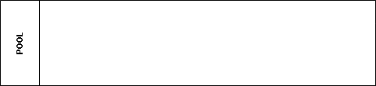

* + - **Lane:** Lane is used to distinguish and draw the activities of the subjects participating in the process. Therefore, Lane's name is often the name of a class of personnel with similar roles, or a business unit, etc. involved in performing the work in the process. Lanes in the same Pool represent classes of personnel, units,.. in the same organization participating in the process. Draw operations performed by an object on the correct lanes of that object.

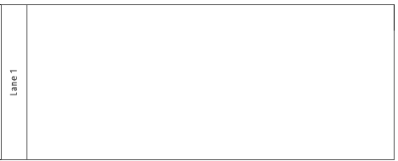

For example use Pool and Lane in Process:

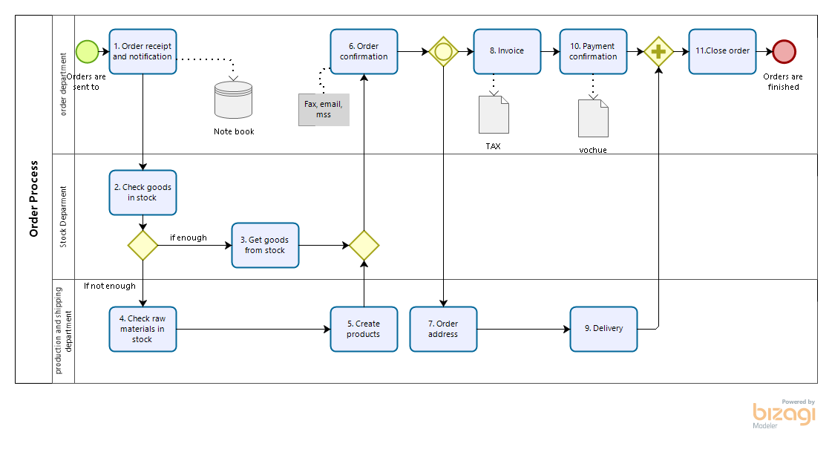

Note:

* + - It is recommended to draw the flowchart in the Pool and the symbols completely in the Pool.
    - Do not create redundant Lanes, Lanes without any activity.
    - Do not draw symbols that lie between the boundaries of Lanes and Pools (except connections).

1. **Message flow:**
   * + In practice many processes are carried out with the exchange of information by stakeholders that may or may not be in the same organization. The BPMN allows you to draw a flowchart describing this information exchange using information connection notation.
     + Không sử dụng kết nối thông tin giữa các thành phần trong cùng một quy trình.
       - ***Draw information connections between processes:*** Draw an information connection from one Pool's process component to another Pool's contour, or conversely, from one Pool's contour to another Pool's process component. In the above flowchart, a Pool will draw a complete flowchart, and is called a white box. The remaining pool will not draw any process flowcharts in it, named the Pool after the name of the information exchange object, this Pool is also known as the black box (Black box) because we do not care about the process. internal process within it, only interested in the process drawn in the remaining Pool.

For example:

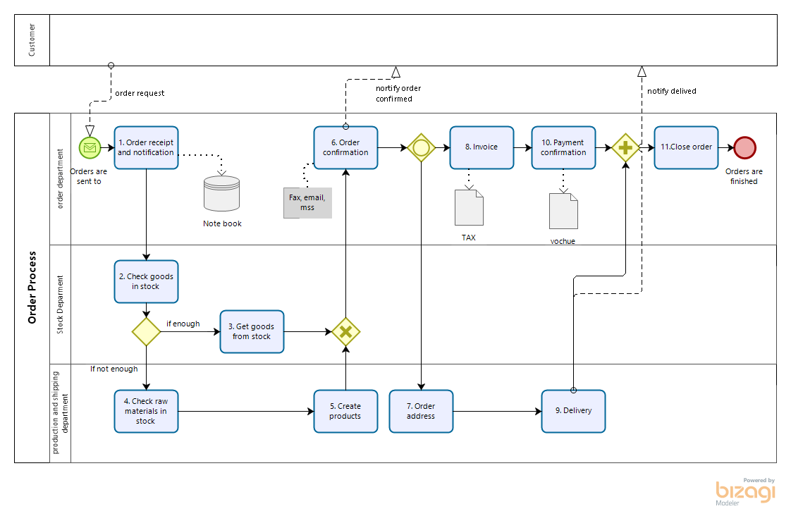

* + - * ***Draw the flow of collaborative information connection between processes:*** Draw the complete flowchart into Pools as usual. The pools should be placed parallel to each other. Draw the communication flow connecting from one process component to another.

For example:

